>1

>ls

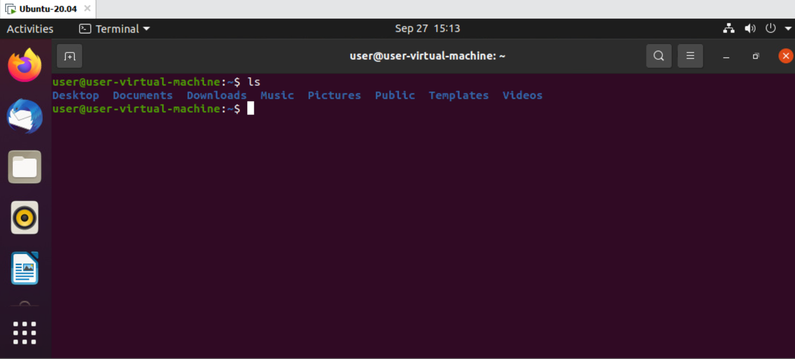

>ls- lists all directories.

>2

>cd Desktop

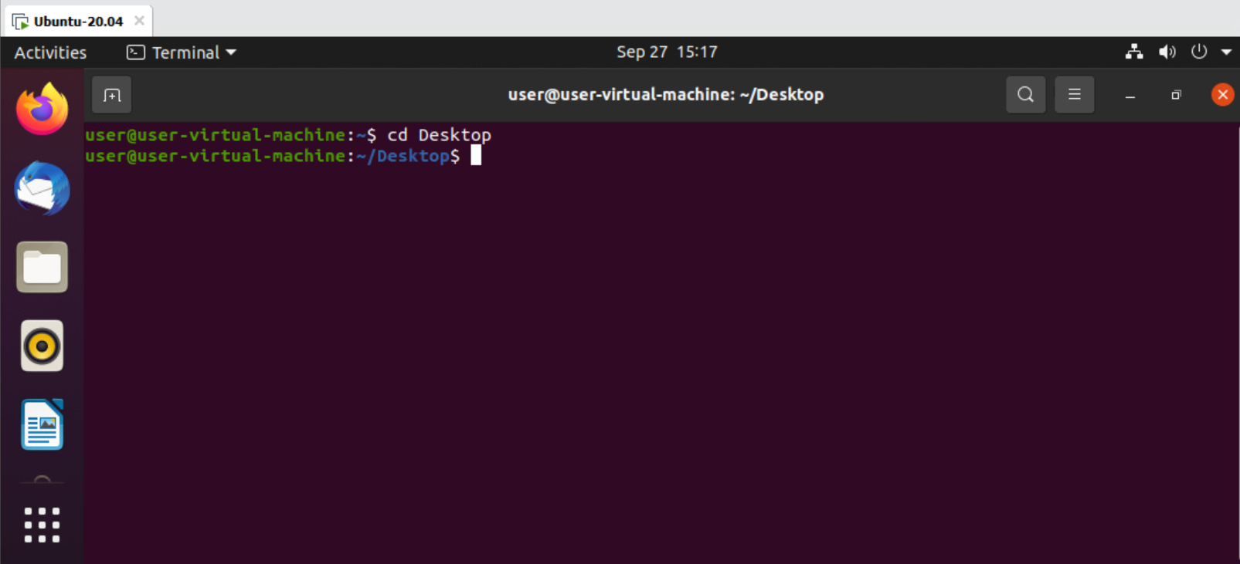

>cd- helps in changing directory.

>3

>cd .

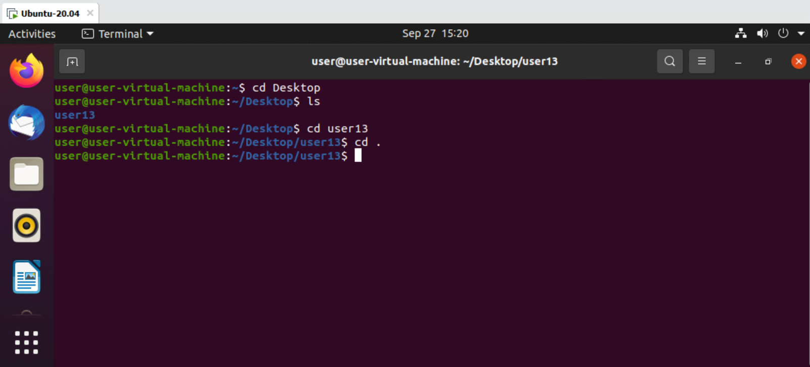

>cd .- shows current directory.

>4

>cd ..

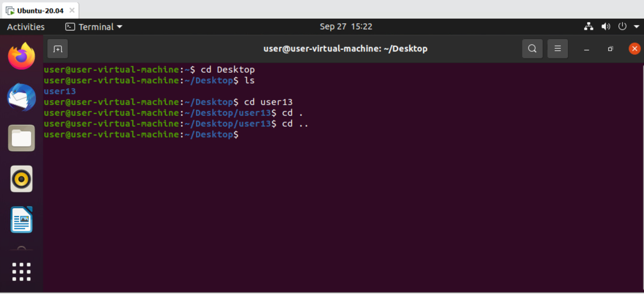

>cd ..- goes to previous directory.

>5

>clear

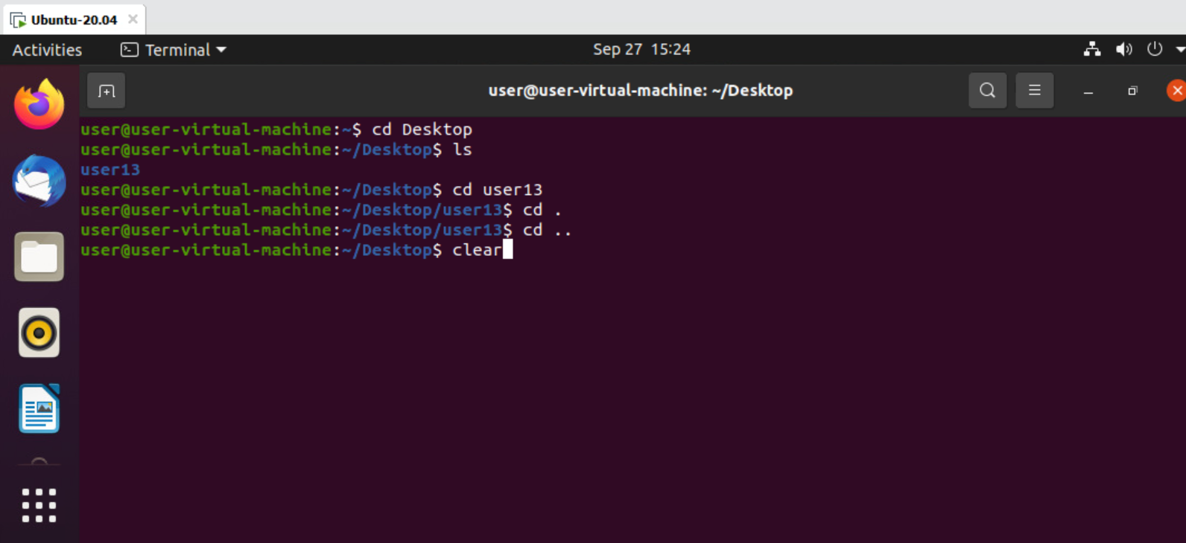

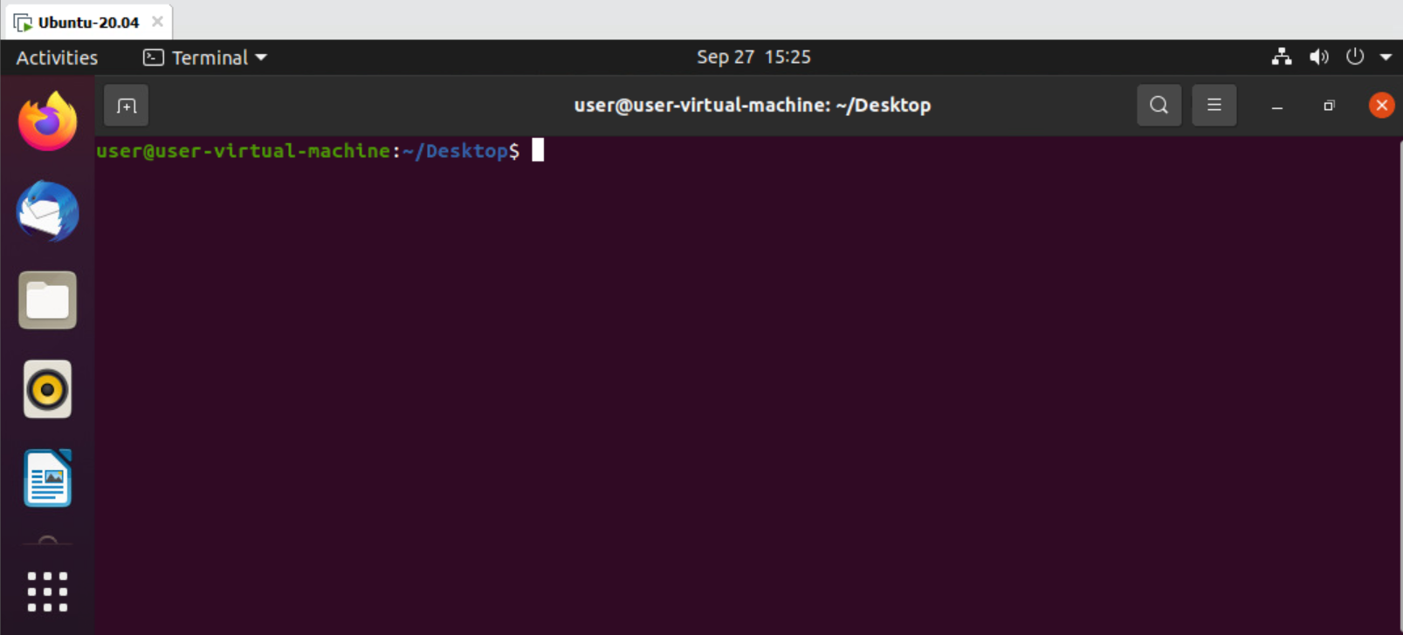

>clear- clear screen.

>6

>cd /

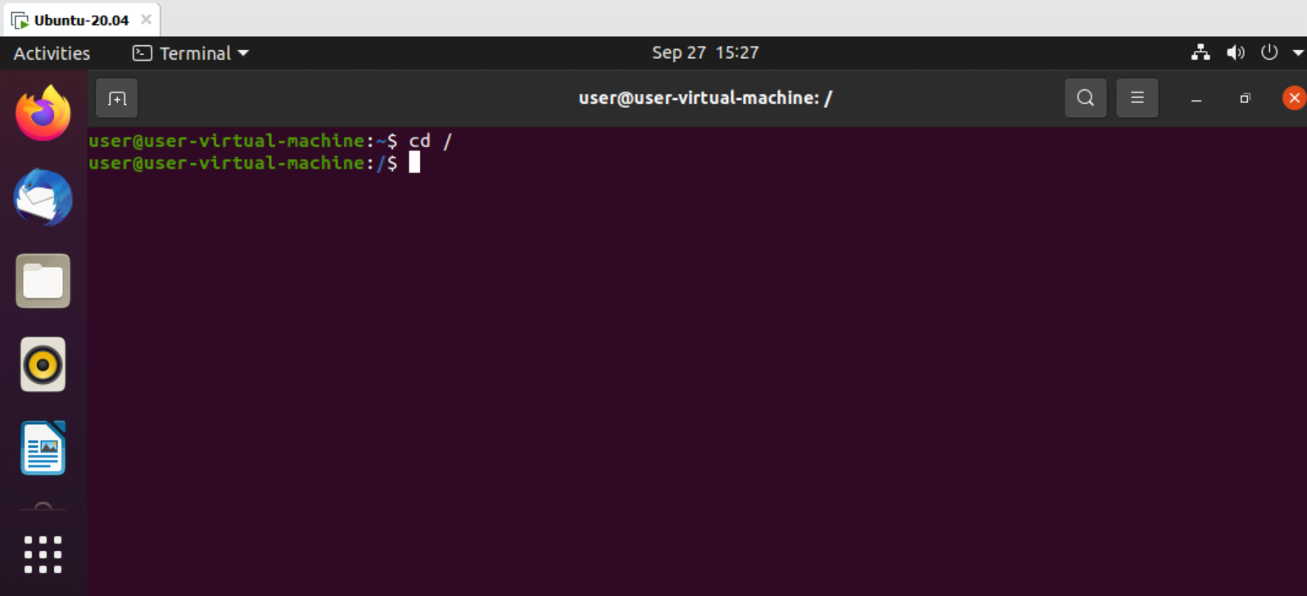

>cd /- normal to root user.

>7

>cd ~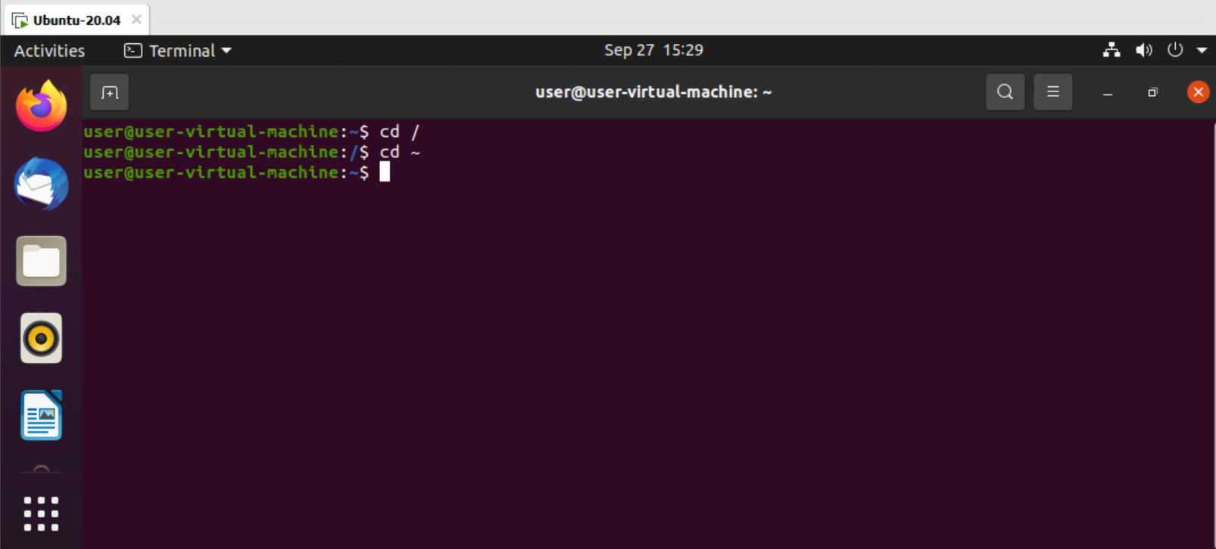

>cd ~- root to normal user.

>8

>ls -a

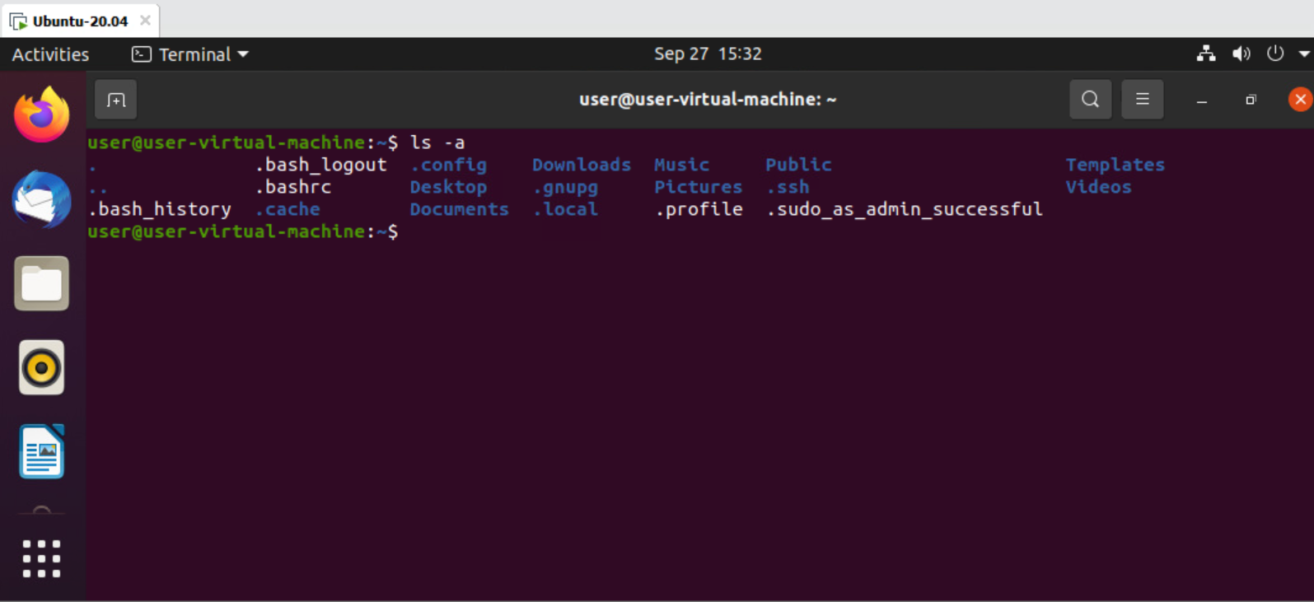

>ls -a- displays all directories along with hidden files.

>9

>ls -A

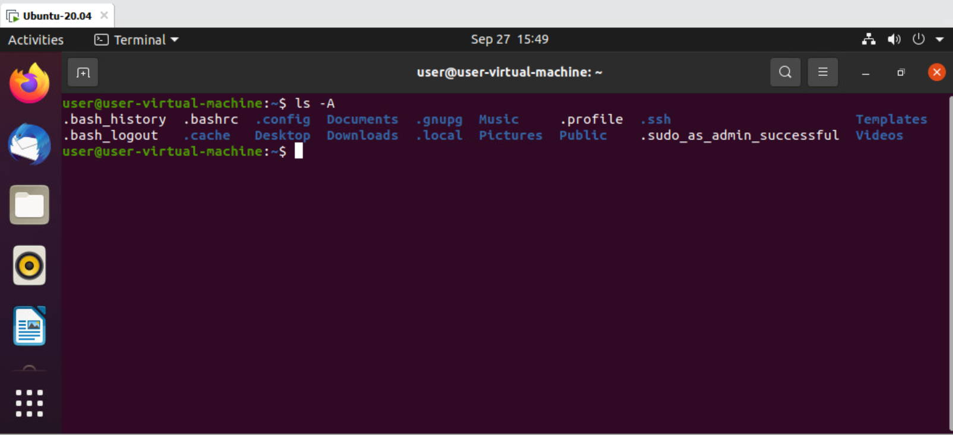

>ls -A- hides current and previous dots.

>10

>sudo -i

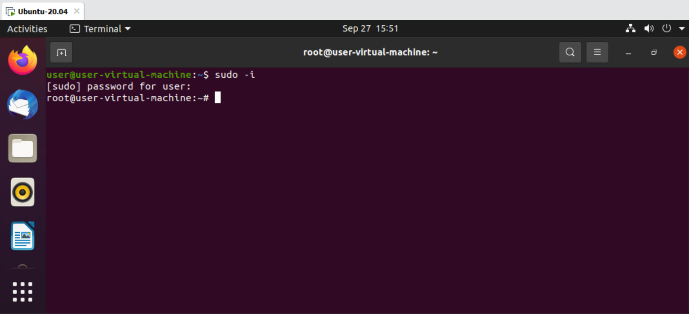

>sudo -i- access permanent root user.

>11

>exit

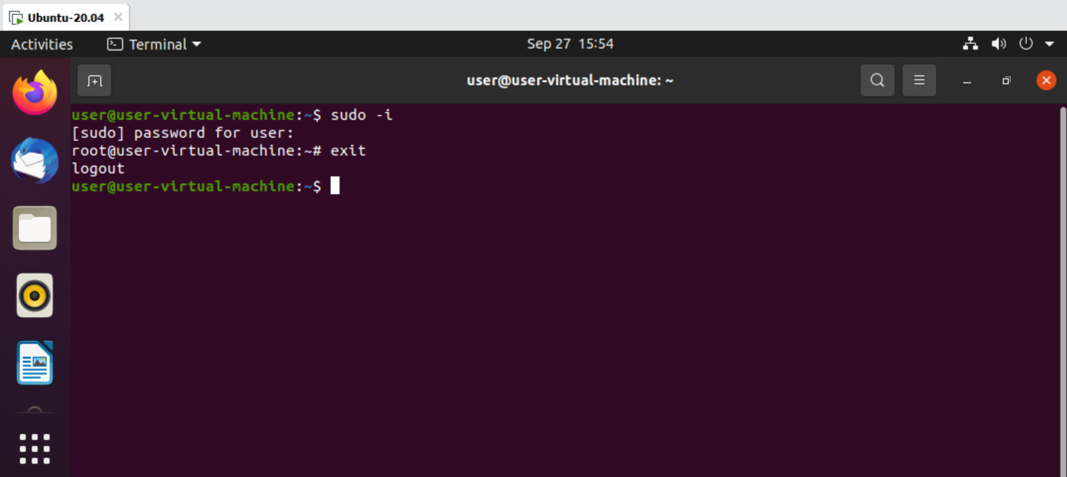

>exit- exit from directory.

>12

>pwd

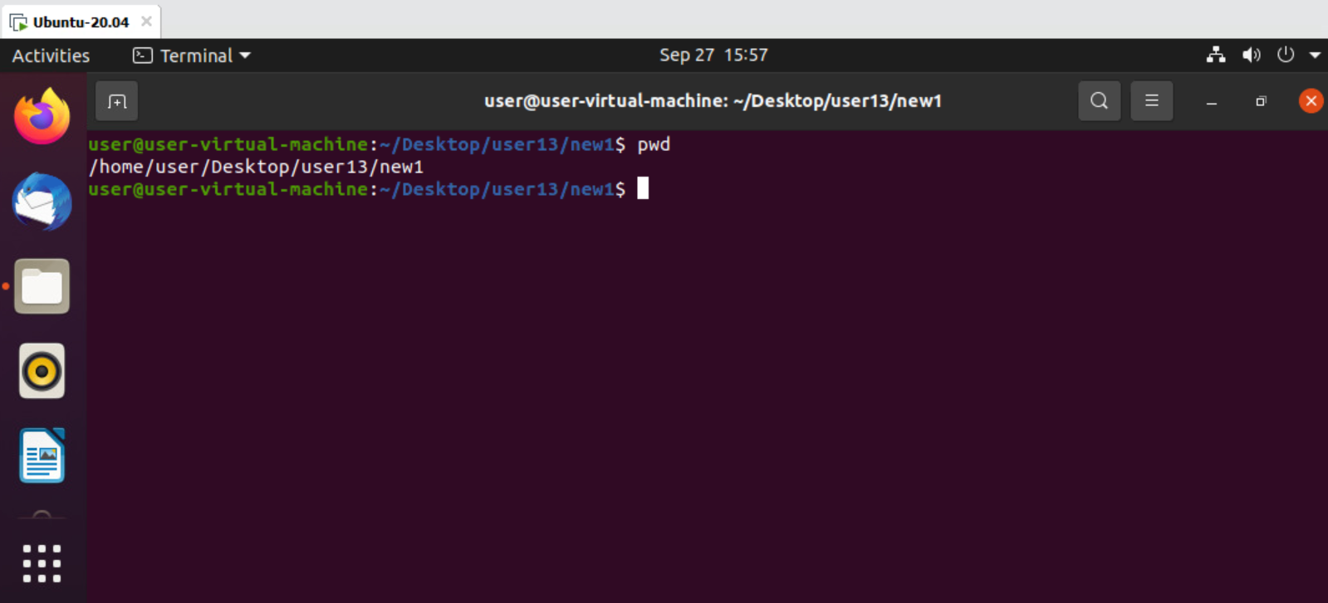

>pwd- current working directory.

>13

>echo “”

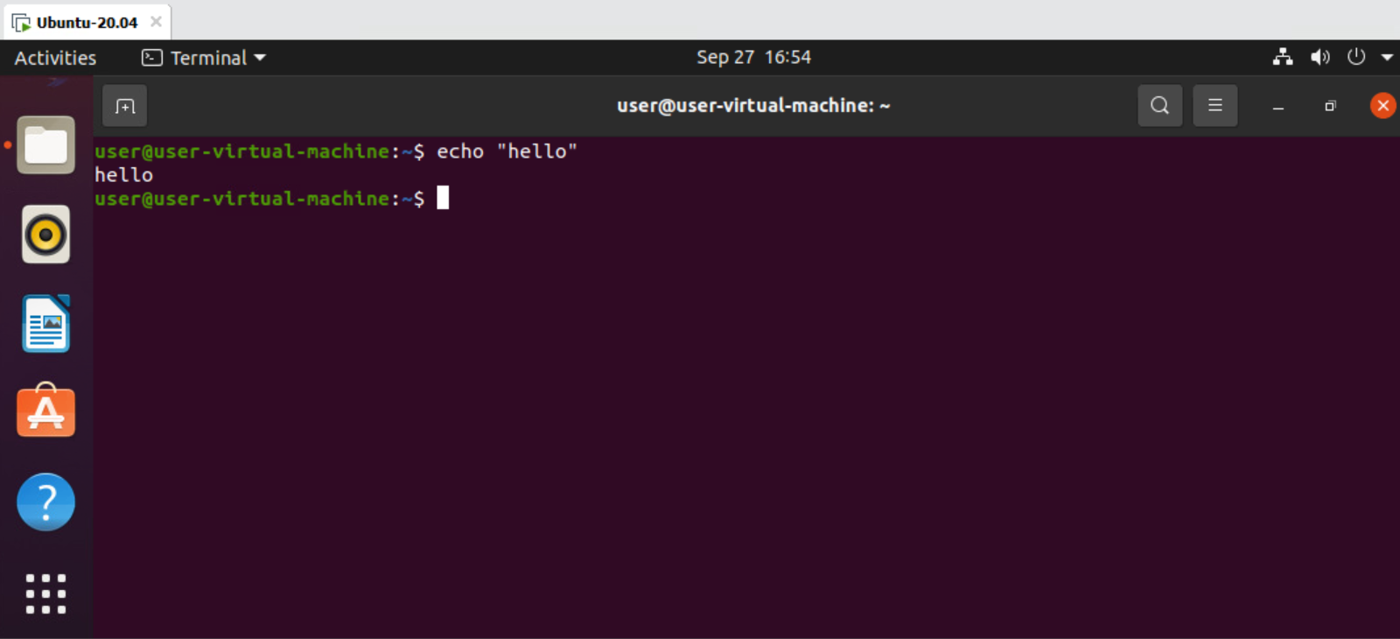

>echo “”- output in terminal.

>14

>ls -l

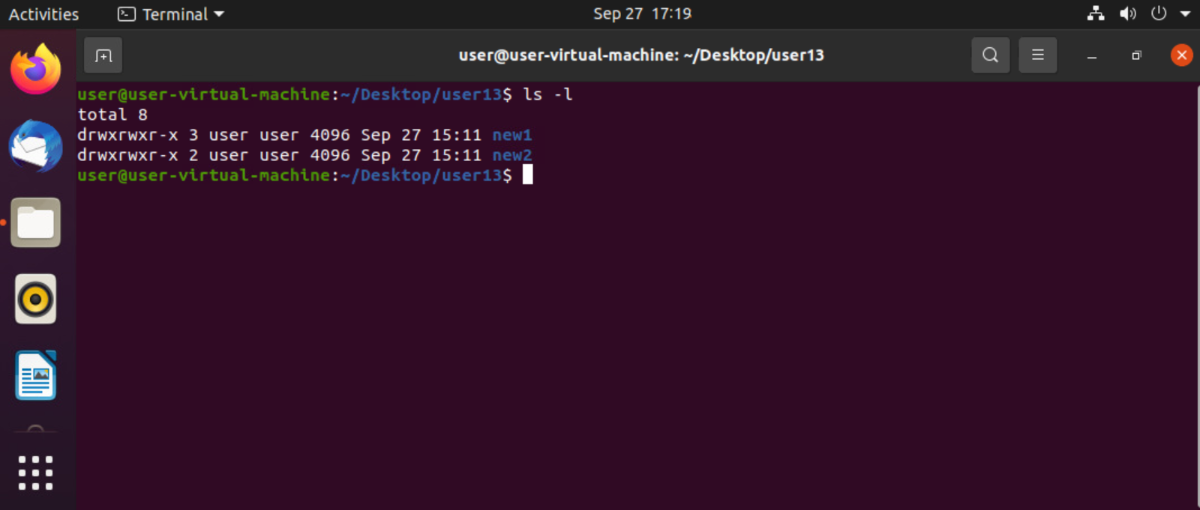

>ls -l- it gives long listed view.

>15

>ls -lh

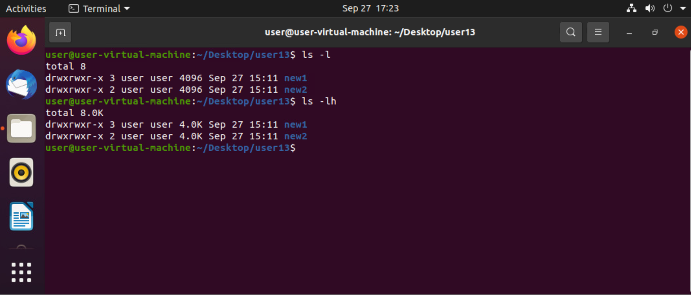

>ls -lh- give readable data size.

>16

>ls -f

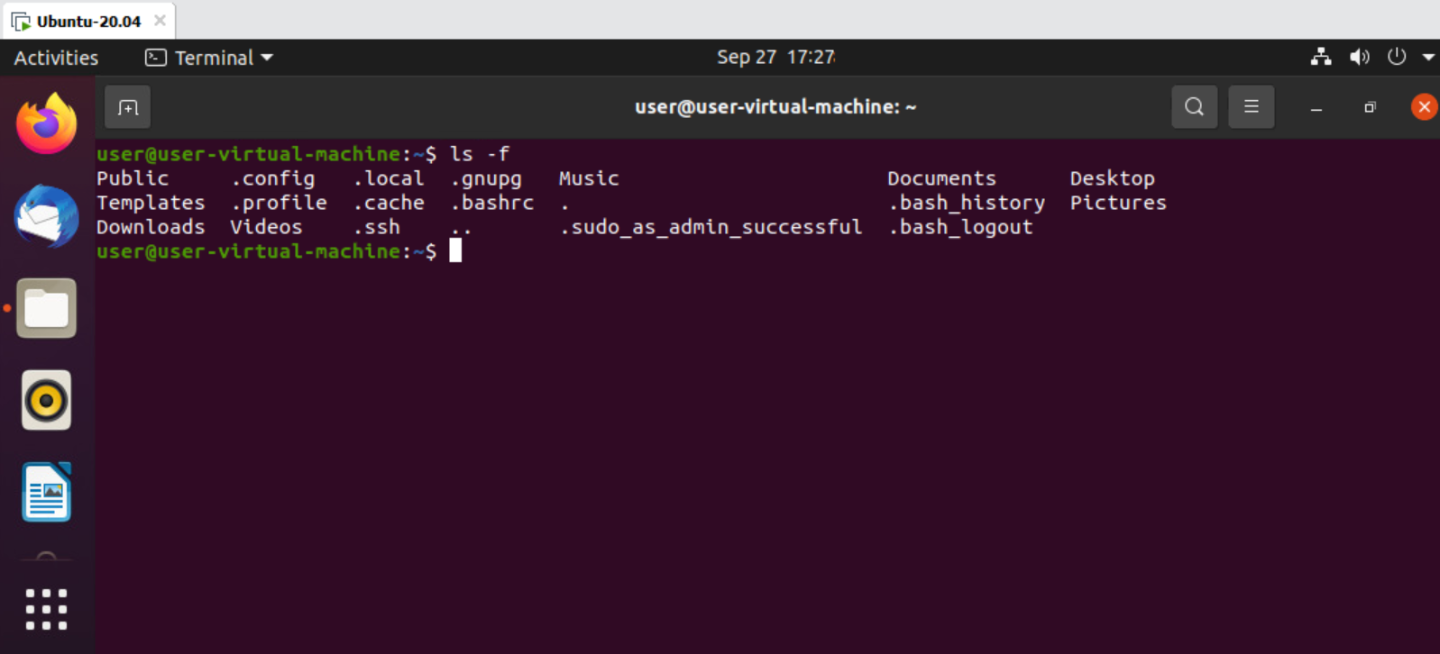

>ls -f- removes color of directories.

>17

>ls -t

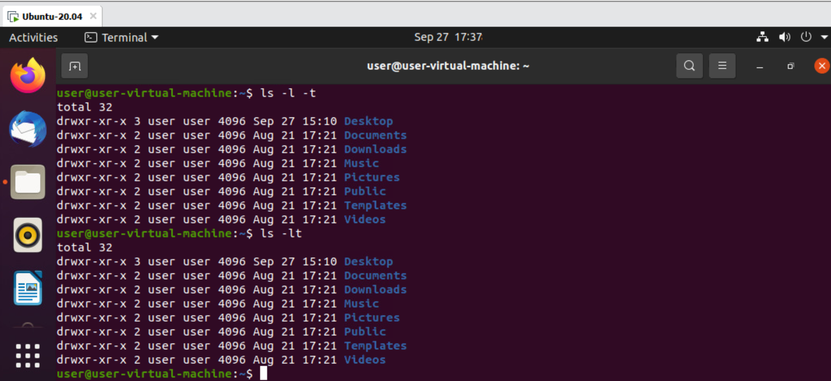

>ls -t- it gives updated time.

>18

>ls -lt



>ls -lt- long list with updated time.

>19

>ls -lt -r

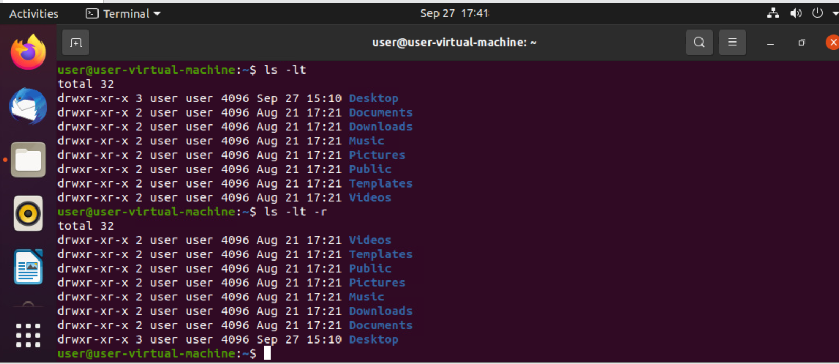

>ls -lt -r- gives reverse order time.

>20

>ls -ltr

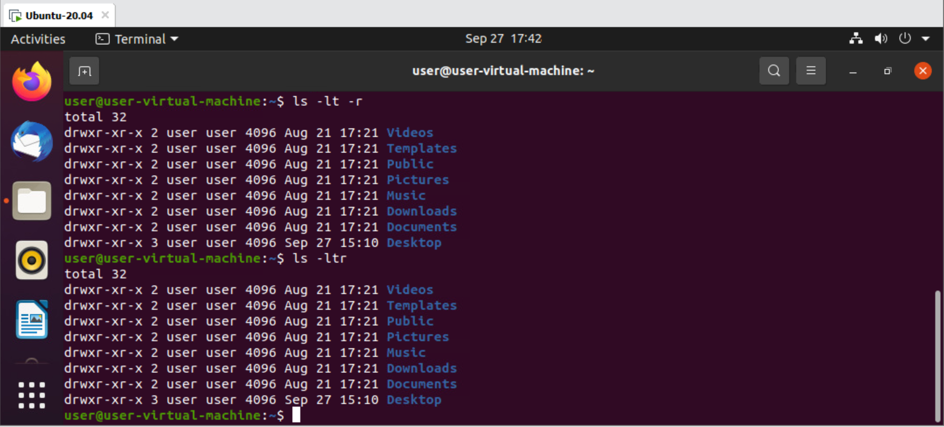

>ls -ltr- gives reverse order of time.

>21

>cat filename

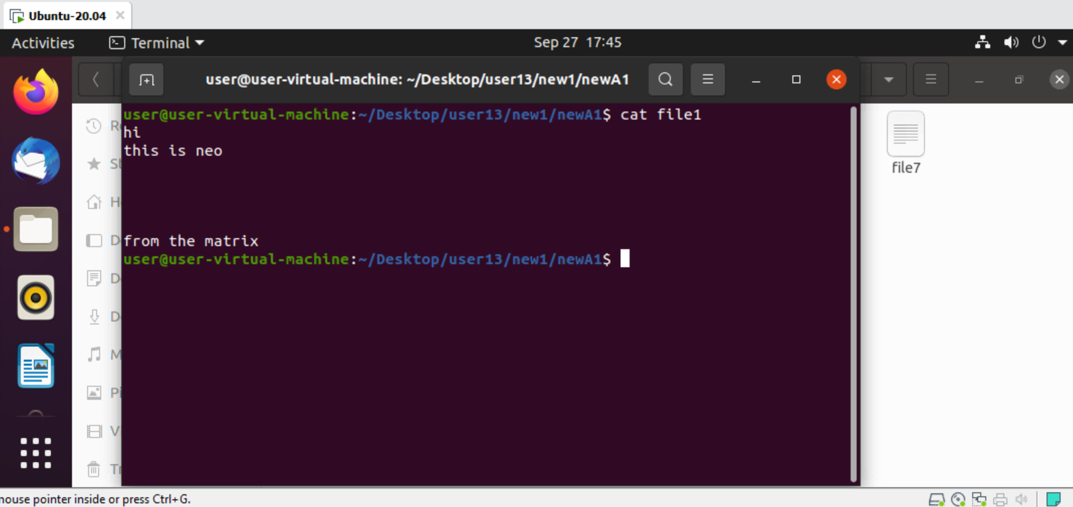

>cat filename- it displays content in file.

>22

>cat \*

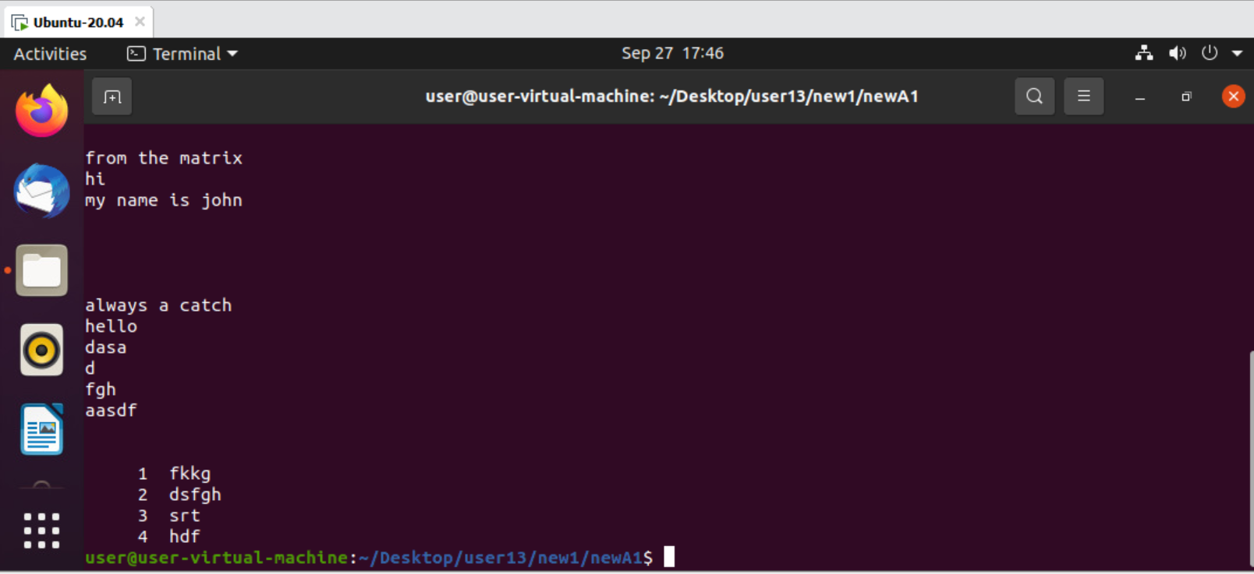

>cat \*- displays all file content.

>23

>cat multiple filenames

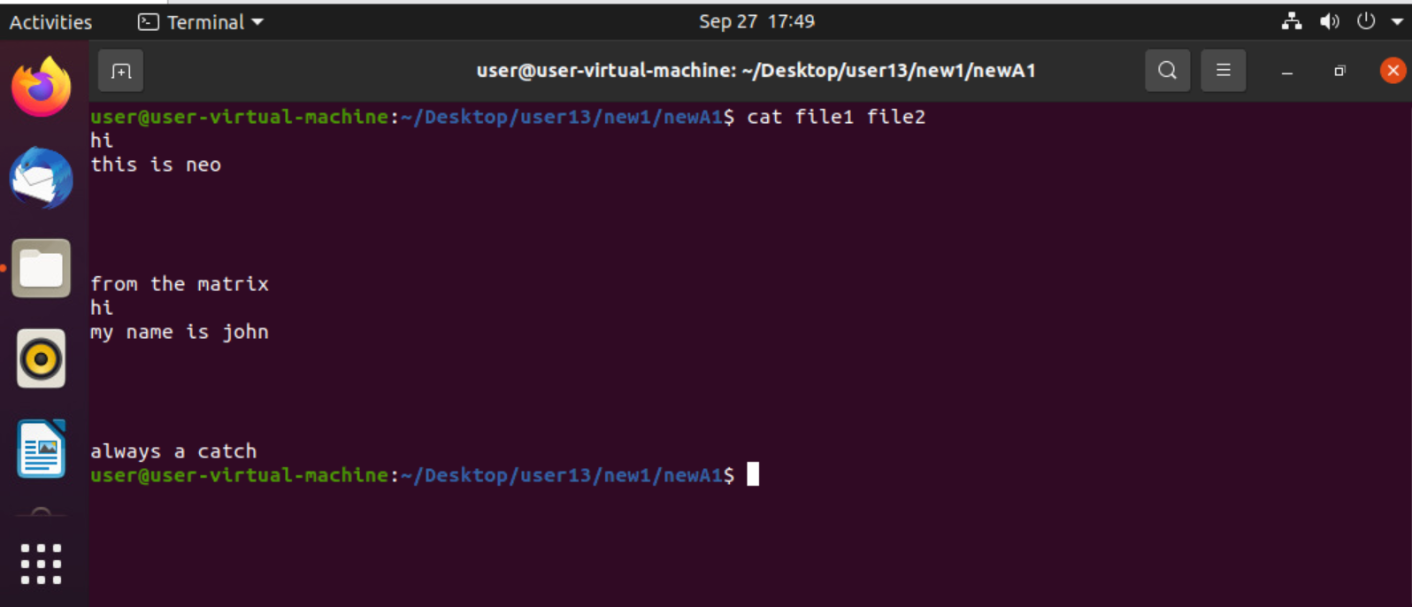

>cat multiple files- displays multiple file contents.

>24

>mv filename filename

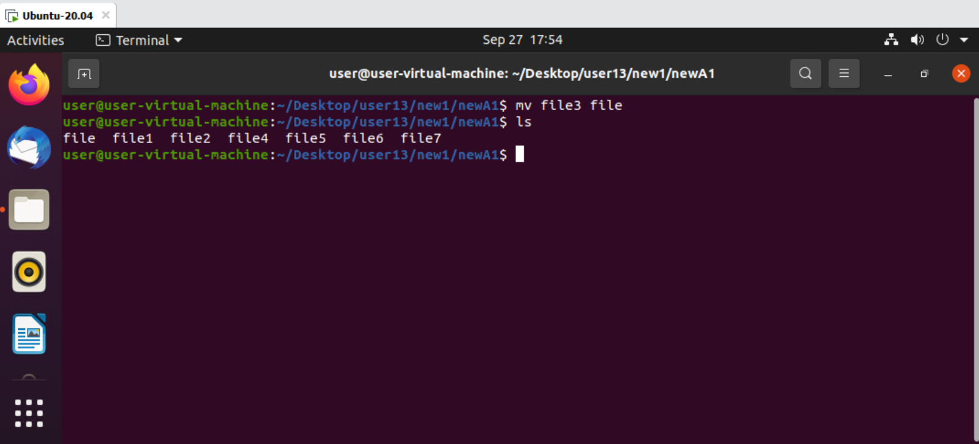

>mv filename filename- moves file to file.

>25

>cat -n filename

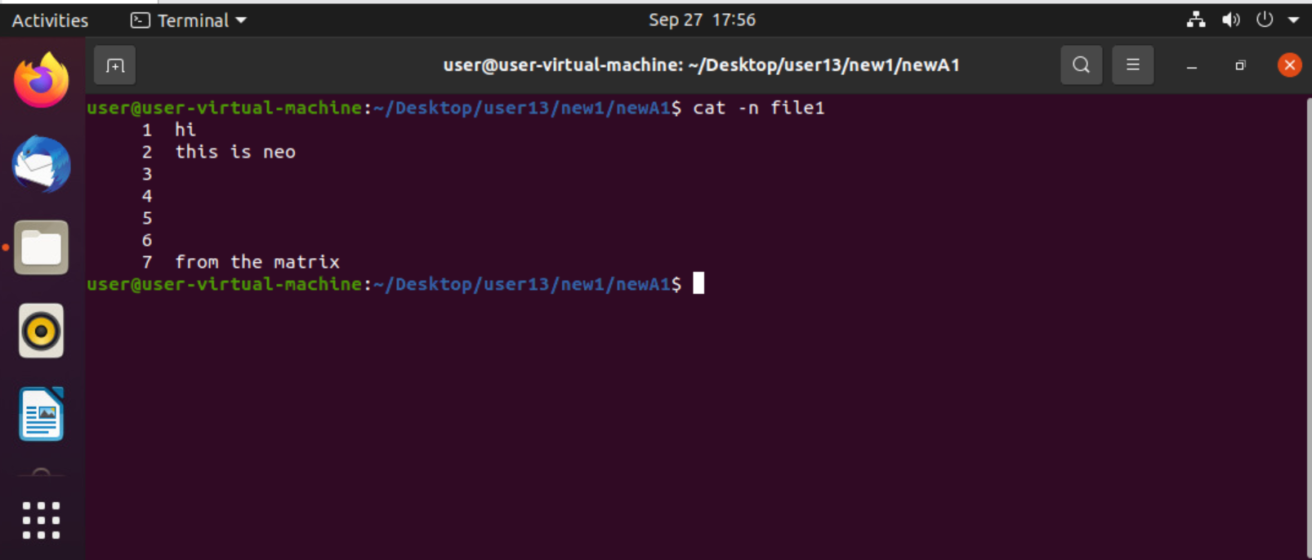

>cat -n filename- displays file lines.

>26

>cat -s filename

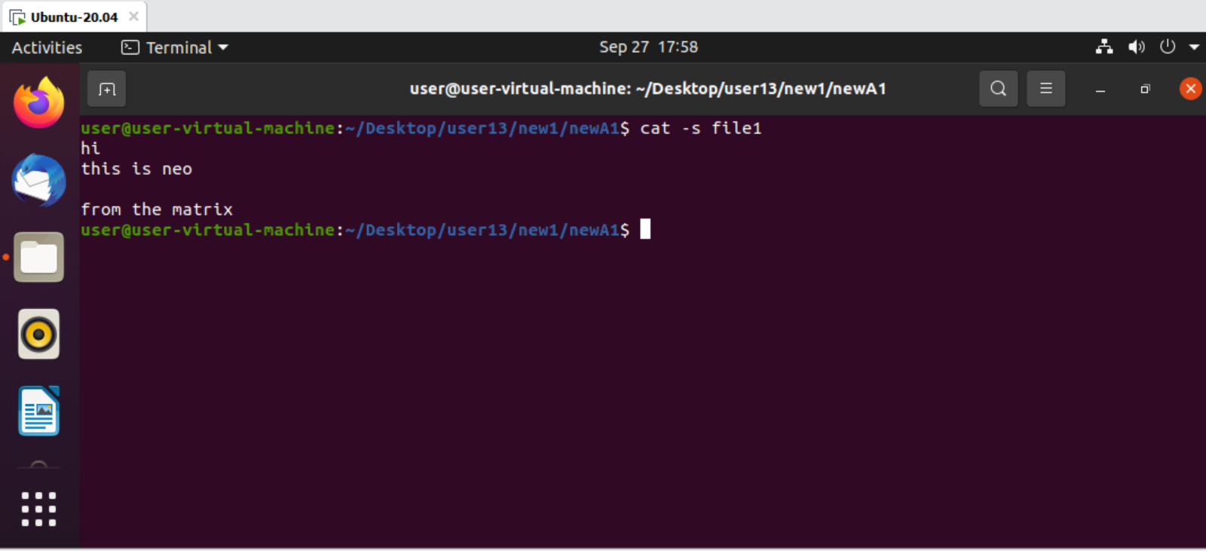

>cat -s filename- removes space from file.

>27

>cat file > file

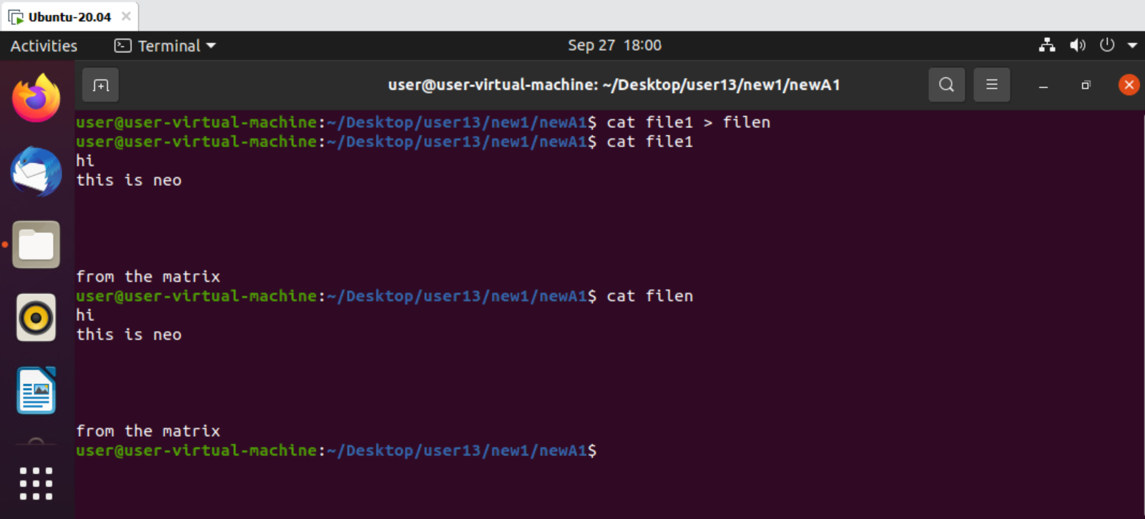

>cat file > file- copies one file to another

>28

>cat > filename

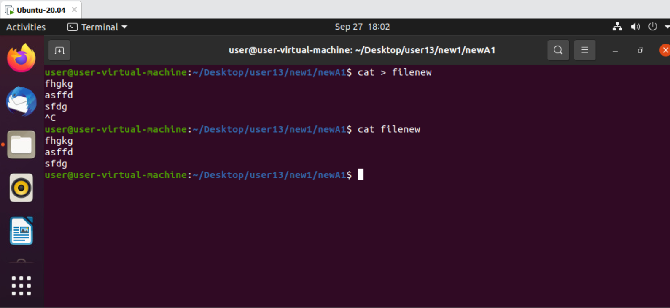

>cat > file- creating new file in terminal.

>29

>cat -n file > newfile

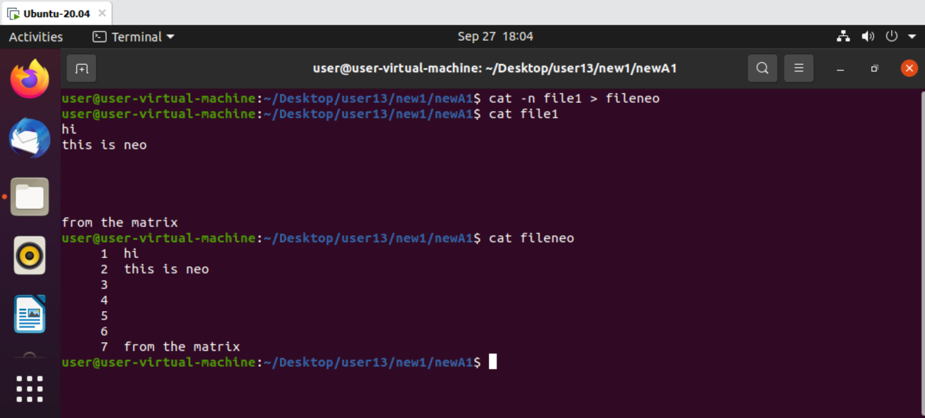

>cat -n file > newfile- creates new file with numbers.

>30

>cat echo ‘’ > file

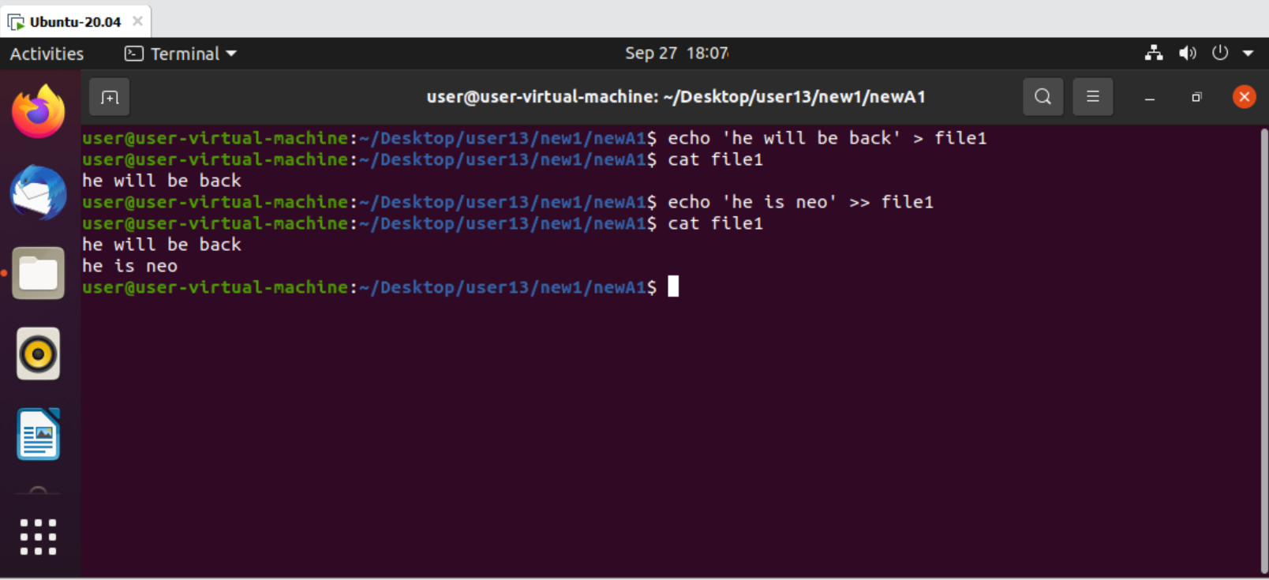

>cat echo ‘’ > file- replace file content.

>31

>cat echo ‘’ >> file



>cat echo ‘’ >> file- adds content in file.

>32

>tac filename

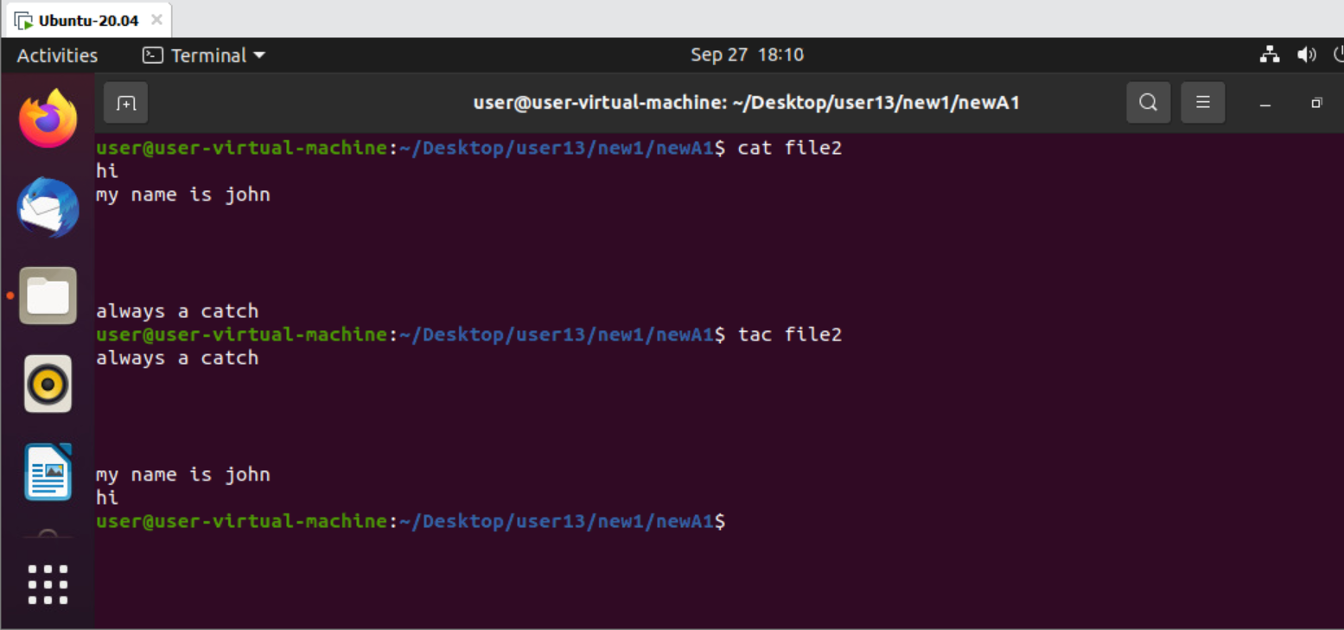

>tac filename- gives reverse order of content.

>33

>cat -E filename

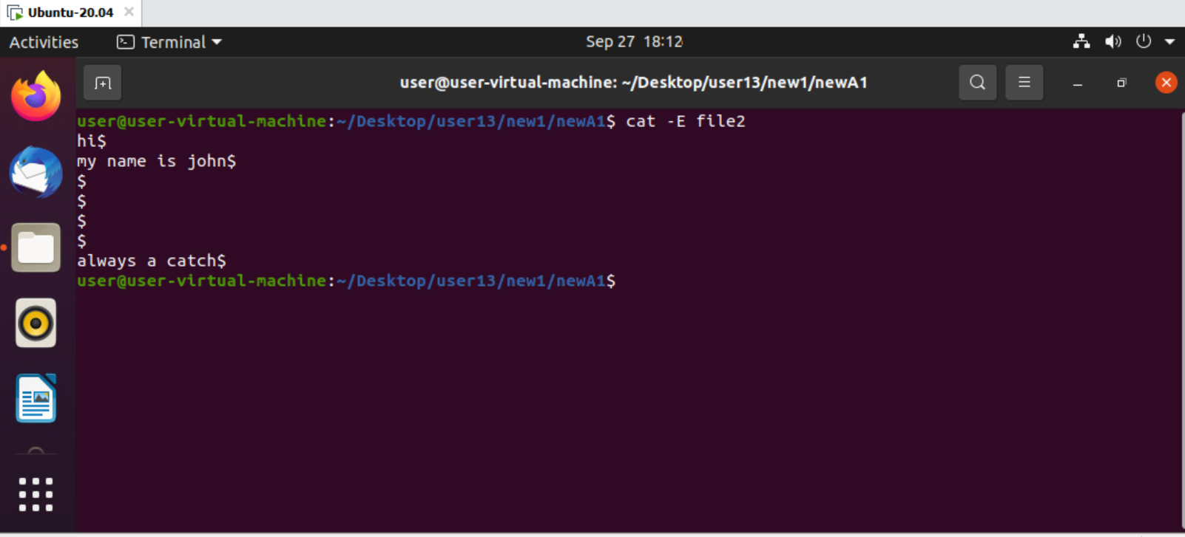

>cat -E filename- gives count of how many times enter key pressed.

>34

>cat -t filename

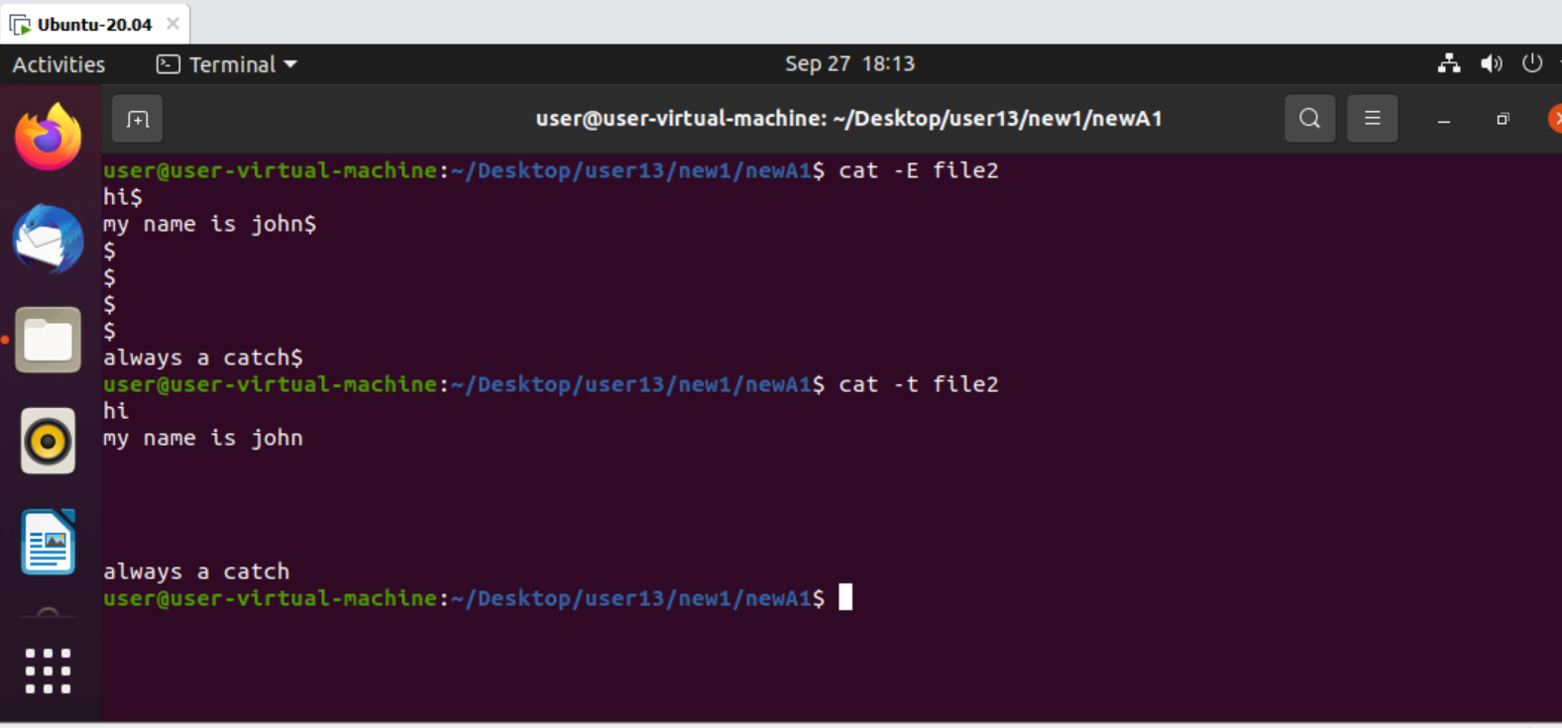

>cat -t filename- gives count of how many times tab pressed.

>35

>cat -tE filename



>cat -tE filename- gives both enter and tab.

>36

>cat filename filename > filename

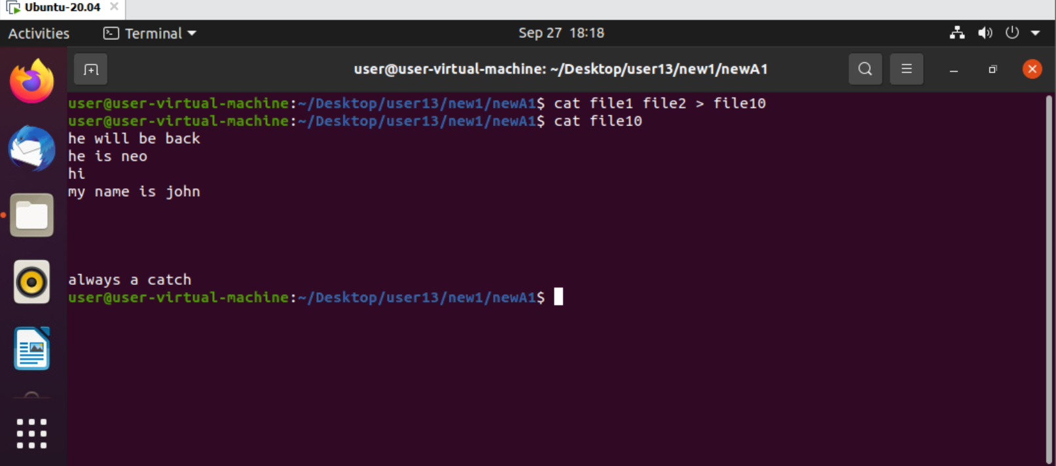

>cat filename filename > filename- add multiple files content to destination file.

>37

>whoami

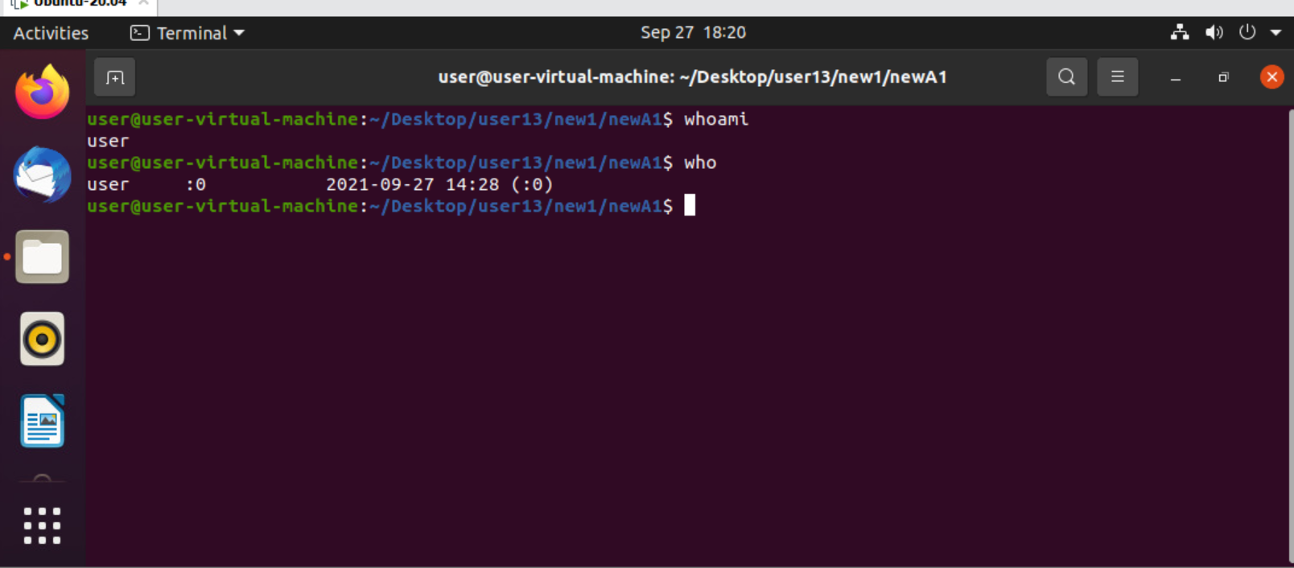

>whoami- who is the user.

>38

>who



>who- who using the system with time.

>39

> --help

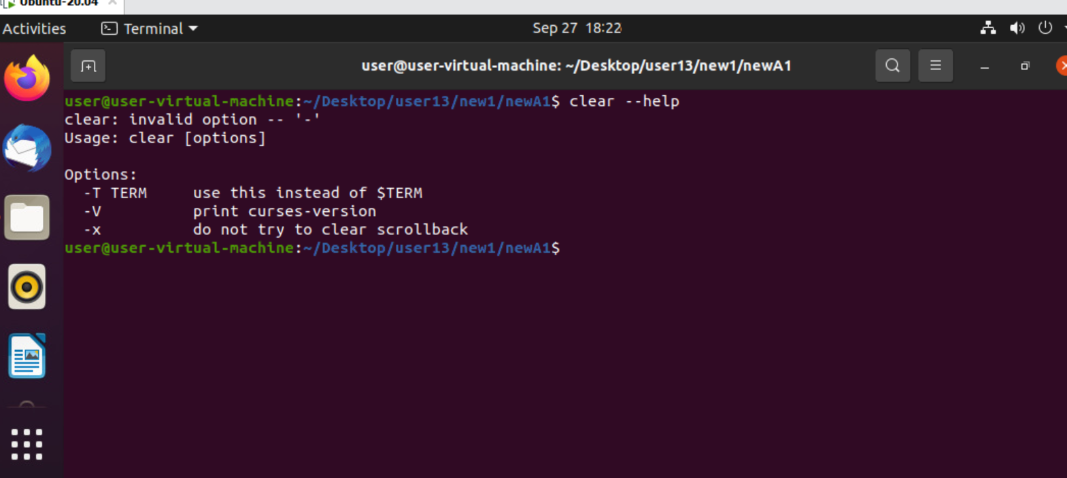

> --help- summarized info. Of key.

>40

>man command

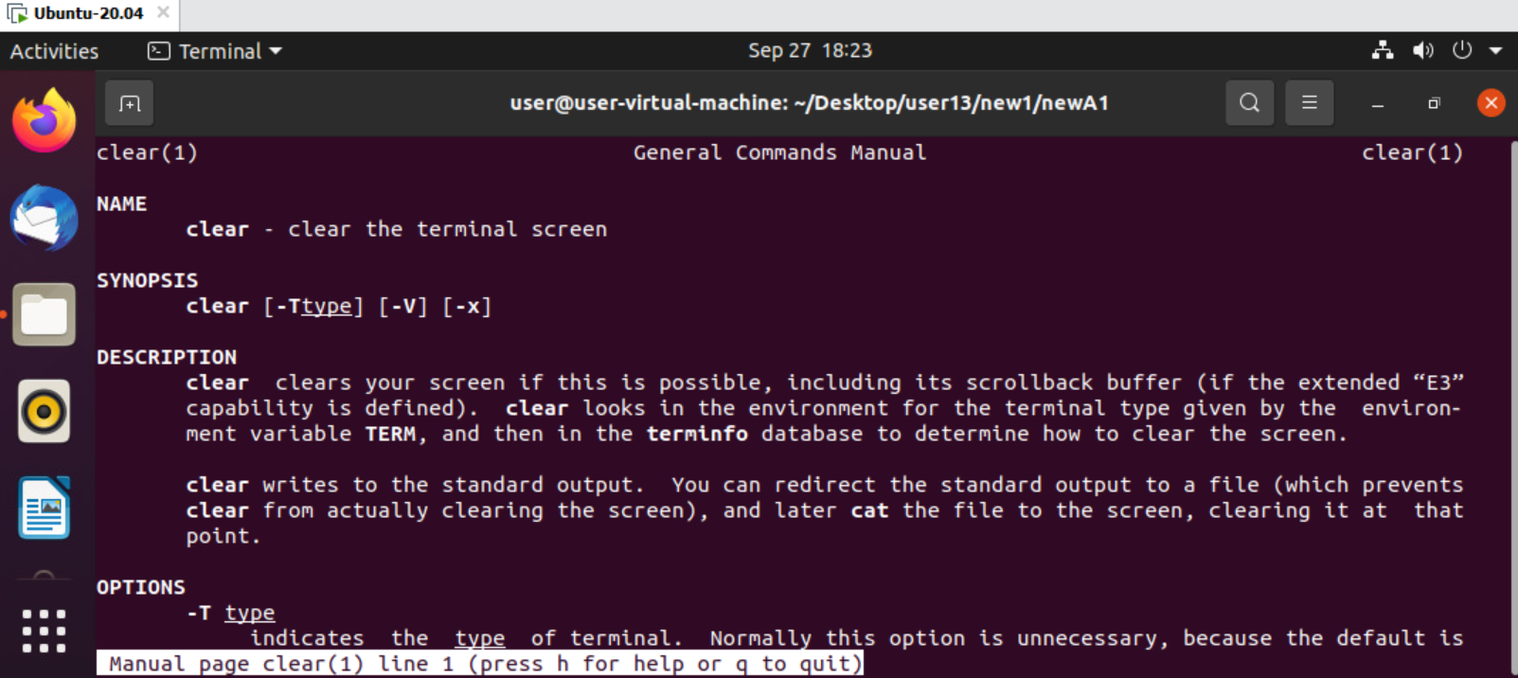

>man command- detailed info. About command.